1. For reading the data from collection , we are going to write cloud function
2. We already seen the cloud function for writing the data , same steps we should follow the same steps for creating the cloud function
3. Example for reading the documents
4. 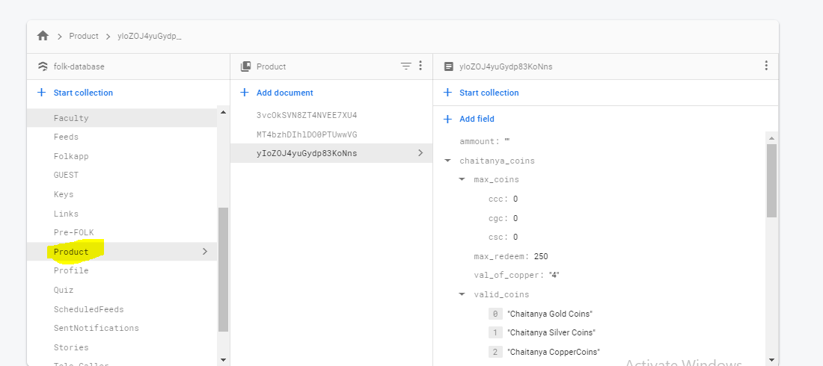
5. docs = db.collection(u’Product’).stream()

for doc in docs:

print(doc.to_dict())

1. the above code prints all the documents data